Microsoft PowerPoint is a popular presentation software developed by Microsoft and included in the Microsoft Office suite. It is widely used in education, business, training sessions, seminars, and professional environments to present information in a clear, organized, and visually attractive way. PowerPoint allows users to create slide-based presentations that help communicate ideas effectively to an audience.
POWERPOINT
Using Microsoft PowerPoint, users can insert and format text, images, charts, tables, shapes, SmartArt graphics, and multimedia elements such as audio and video. The software also provides various themes, slide layouts, and design tools that help maintain consistency and improve the overall appearance of a presentation. Features like animations and slide transitions make presentations more engaging and help emphasize important points.
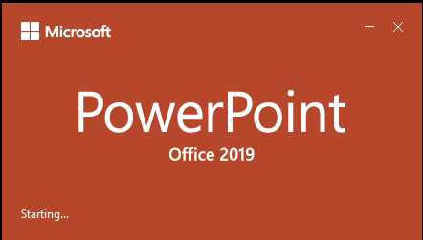
Microsoft PowerPoint also supports easy editing, formatting, and integration with other Microsoft Office applications such as Word and Excel. This makes it convenient to prepare presentations using data, reports, and documents from different sources. Overall, Microsoft PowerPoint is an essential tool for creating professional, informative, and visually appealing presentations, making it suitable for practical work and lab report documentation.
1. PowerPoint Start Screen
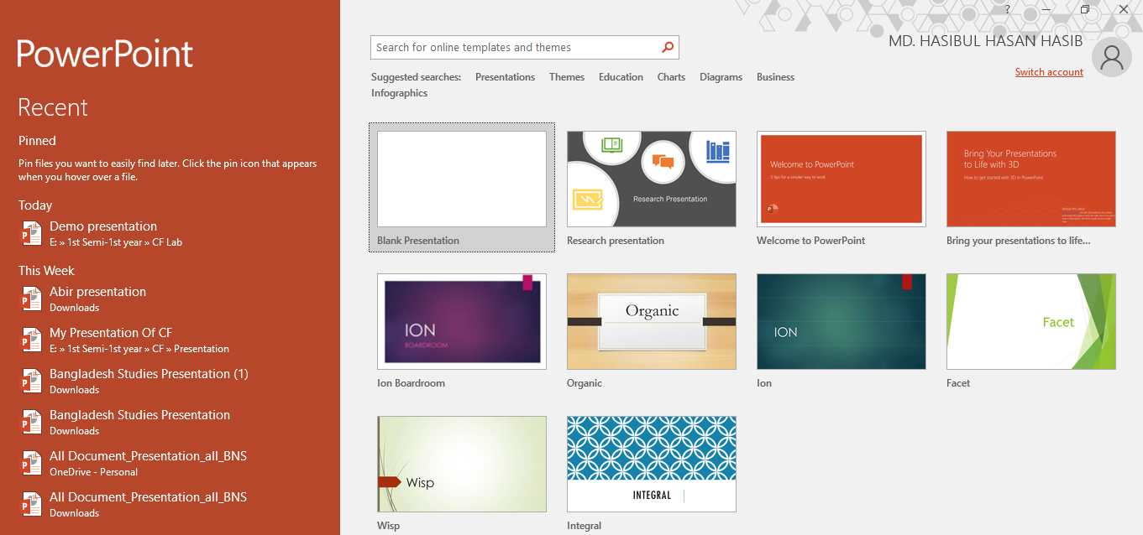
PowerPoint Start Screen is the first screen that appears when Microsoft PowerPoint is opened. It allows users to quickly create a new presentation by choosing a blank presentation or selecting from available templates and themes. The Start Screen also provides access to recently opened files, making it easy to continue working on previous presentations.
Template
Search Bar
2.Powerpoint Interface
Microsoft Office Interface refers to the overall layout and visual structure of Microsoft Office applications that helps users interact with the software easily and efficiently. It includes key elements such as the title bar, ribbon, tabs, groups, quick access toolbar, and status bar. This interface is designed to organize tools and commands logically, allowing users to access features quickly, perform tasks smoothly, and work productively across different Microsoft Office programs.
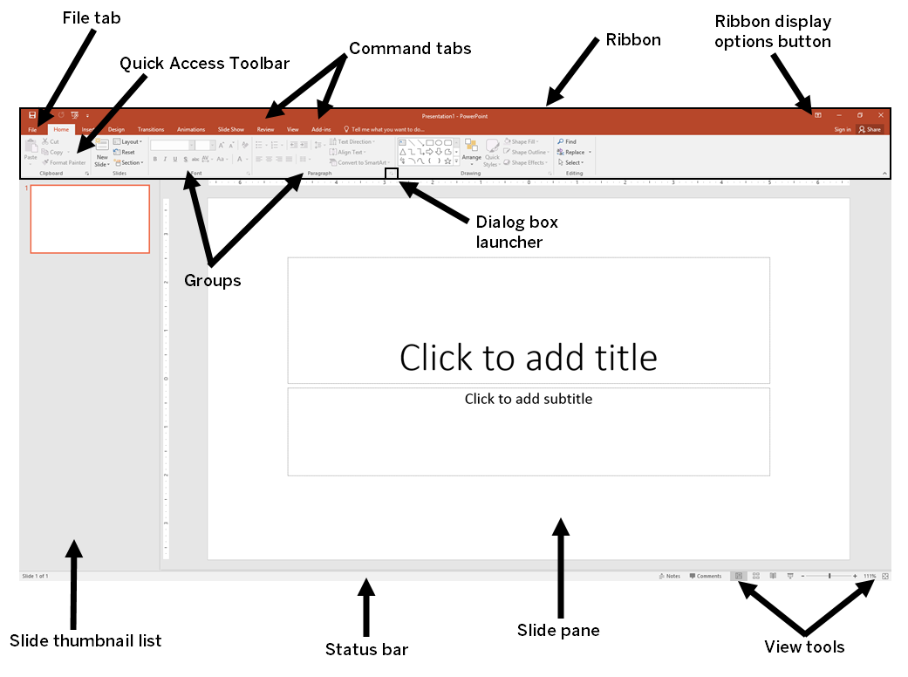
- File tab: Opens Backstage view to manage files such as New, Open, Save, Print, and Options.
- Quick Access Toolbar: Provides quick access to frequently used commands like Save, Undo, and Redo.
- Command tabs: Tabs (Home, Insert, Design, etc.) that organize related tools and commands.
- Ribbon: The main toolbar area that displays commands related to the selected tab.
- Ribbon display options button: Controls how the Ribbon is shown (auto-hide, show tabs, or show full ribbon).
- Groups: Sections within a Ribbon tab that organize related commands (e.g., Font, Paragraph).
- Dialog box launcher: A small arrow that opens a dialog box with more detailed settings for a group.
- Slide thumbnail list: Displays thumbnails of all slides, allowing quick navigation and reordering.
- Status bar: Shows presentation information such as slide number, notes, and view status.
- Slide pane: The main working area where the current slide content is created and edited.
- View tools: Buttons to change slide views (Normal, Slide Sorter, Reading, Slide Show).
3.Home
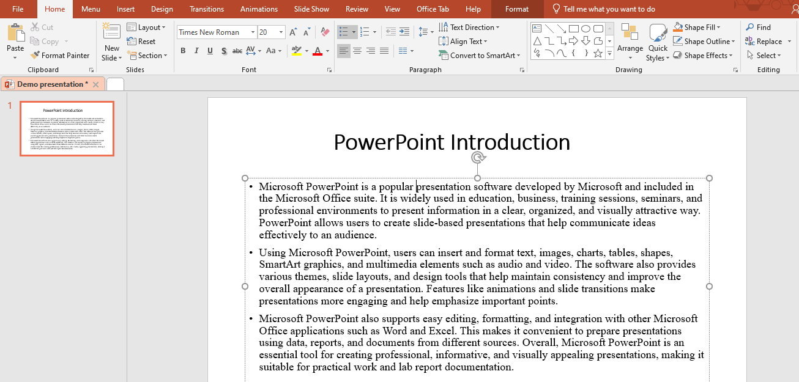
MS PowerPoint Home Tab is the main working tab in Microsoft PowerPoint that contains the most commonly used tools for creating and editing slides. It includes options for adding and formatting text, inserting new slides, changing slide layouts, adjusting fonts and paragraphs, and managing objects such as shapes and images. The Home tab helps users perform basic editing tasks quickly and efficiently while designing presentations.
Paragraph
Drawing
Editing
Font
Slides
Sides Pane

Home tab feature
- Slides Pane: The Slides group is used to manage slides in a presentation. It allows users to create a new slide, choose different slide layouts, duplicate slides, delete slides, and reset slide formatting. This feature helps organize the structure and flow of the presentation.
- Slides: The Slides area displays thumbnails of all slides in the presentation. It allows users to easily navigate between slides, rearrange their order by dragging, and get an overview of the entire presentation. This helps in organizing and reviewing slides efficiently.
- Font: The Font group is used to format text on slides. It includes options to change the font type, size, color, and style such as bold, italic, and underline. Users can also apply text effects to make the content more clear and visually attractive.
- Paragraph: The Paragraph group controls the alignment and spacing of text. It allows users to align text left, right, center, or justify, adjust line spacing, create bullet points and numbering, and control text indentation. This helps improve the readability and presentation of text.

- Drawing: The Drawing group provides tools for inserting and formatting shapes. Users can draw shapes, apply fill colors, outlines, and effects, and arrange objects on slides. This feature is useful for creating diagrams, flowcharts, and visual elements.
- Editing: The Editing group includes tools such as Find, Replace, and Select. These tools help users quickly locate text, replace words or phrases, and select objects on a slide. This feature saves time and improves editing efficiency.
4.Insert
Insert Tab in Microsoft PowerPoint is used to add different types of content to a presentation. It allows users to insert text boxes, pictures, shapes, tables, charts, SmartArt graphics, icons, audio, and video into slides. The Insert tab helps enhance presentations by adding visual, graphical, and multimedia elements, making the content more informative, interactive, and visually appealing.
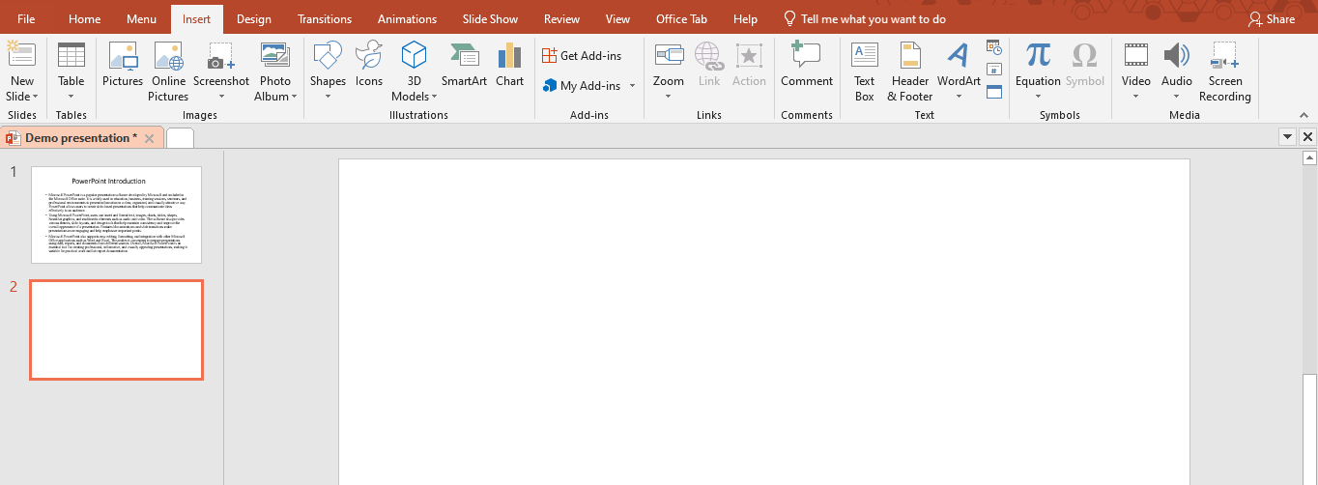
Media
Images
Illustration
Font
Tables
New Slide
- New Slide: The New Slide feature is used to add a new slide to the presentation. Users can choose different slide layouts to organize content properly. This helps in structuring the presentation in a clear and logical way.
- Tables: The Tables feature allows users to insert tables into slides to organize data in rows and columns. Tables are useful for presenting information clearly, such as comparisons, schedules, or numerical data.
- Images: The Images feature is used to insert pictures into slides from a computer or other sources. Images help make presentations more attractive and support better visual understanding of the content.
- Illustrations: The Illustrations feature allows users to add shapes, icons, SmartArt, and charts. These visual elements are helpful for creating diagrams, flowcharts, and graphical representations of data.
- Font: The Font feature is used to format text on slides. It includes options to change font style, size, color, and text effects, helping improve readability and visual appeal.
- Media: The Media feature allows users to insert audio and video files into slides. This helps create interactive presentations by adding sound effects, narration, or video demonstrations.

5.Design
Design Tab in Microsoft PowerPoint is used to enhance the overall look and feel of a presentation. It provides tools to apply themes, choose slide backgrounds, adjust colors, fonts, and effects, and customize the slide size. The Design tab helps make presentations visually appealing, professional, and consistent in style.
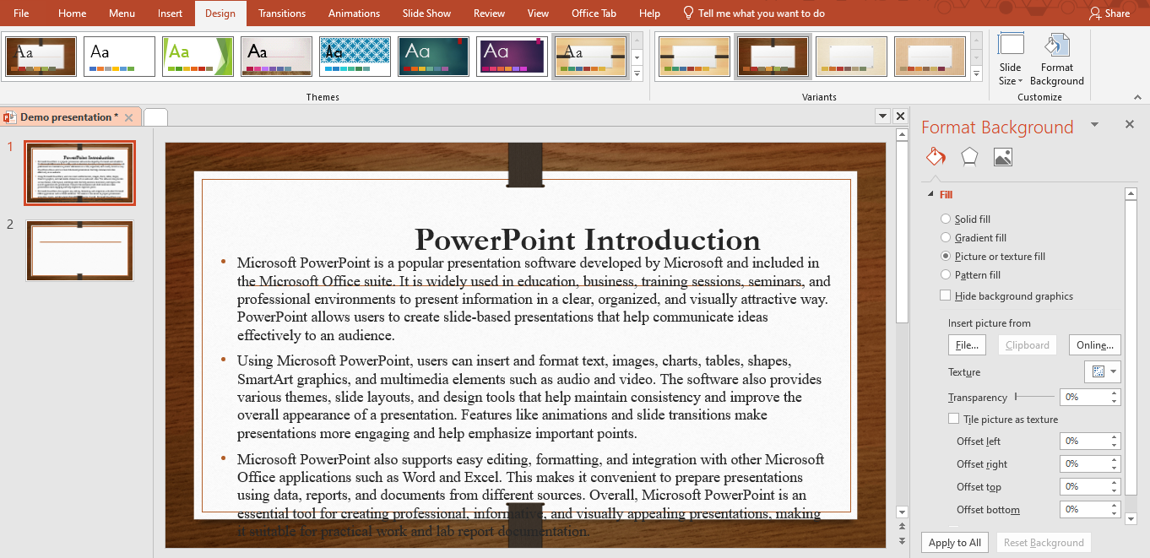
- Themes: The Themes tool allows users to apply a set of coordinated colors, fonts, and effects to all slides, giving the presentation a consistent and professional look.
- Variants: The Variants tool lets users customize a selected theme by changing its color, font style, and effects to better suit the presentation’s style.
- Slide Size: The Slide Size tool allows users to choose the dimensions of slides, such as standard (4:3) or widescreen (16:9), to fit different screens or printing formats.
- Format Background: The Format Background tool enables users to customize the background of slides with colors, gradients, textures, or images, enhancing visual appeal.
6.Transitions
The Transition tab in Microsoft PowerPoint is a powerful tool used to add visual effects when moving from one slide to another during a presentation. Transitions help make a presentation more dynamic and engaging by providing smooth or eye-catching slide changes, which can hold the audience’s attention and improve the overall flow of the presentation. Using transitions effectively can make the content appear more professional and polished.
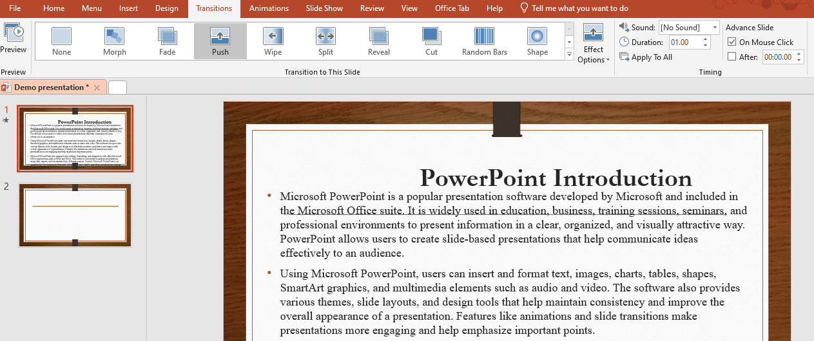

Key Features of the Transition Tab:
- Transition Effects: PowerPoint offers a wide range of transition effects such as Fade, Wipe, Push, Split, and Morph. Each effect provides a unique way for slides to appear or disappear, allowing presenters to choose the style that best suits their content and audience.
- Effect Options: Many transitions can be further customized using Effect Options. For example, you can change the direction of a Wipe or the style of a Split, giving more control over how the slides appear.
- Duration: This feature allows users to control how long each transition takes. By adjusting the duration, presenters can make transitions faster for a quick flow or slower to emphasize a particular slide.
- Apply to All: With this option, the selected transition effect can be applied to all slides in the presentation, ensuring visual consistency and saving time during the design process.
- Advance Slide: Users can set slides to advance manually, such as on a mouse click, or automatically after a specific time. This is especially useful for self-running presentations or timed demonstrations.

6.Animations
The Animations tab in Microsoft PowerPoint is used to apply motion effects to objects on a slide, such as text, images, shapes, charts, or SmartArt. Animations help make presentations more engaging by controlling how and when elements appear, move, or disappear on a slide. Proper use of animations can highlight important information, guide the audience’s attention, and make the presentation more interactive and professional.
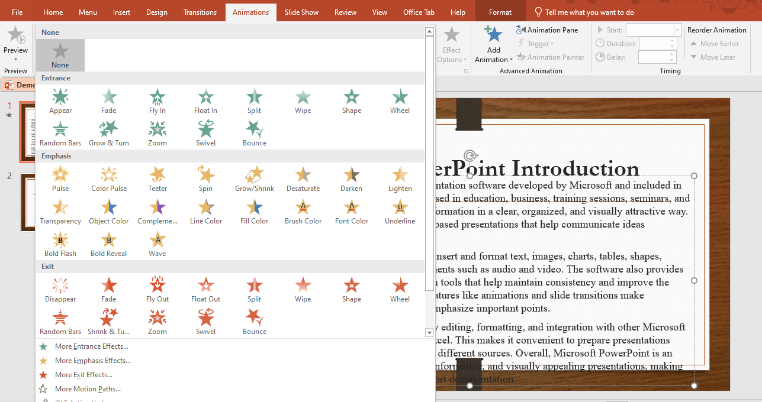
Key Features of the Animations Tab:
- Animation Effects: PowerPoint provides a variety of animation effects, including Entrance (objects appear on the slide), Emphasis (objects draw attention while on the slide), Exit (objects disappear from the slide), and Motion Paths (objects move along a defined path). These effects help present information dynamically.
- Effect Options: Many animations can be customized with Effect Options. Users can adjust the direction, sequence, or style of an animation, giving more control over how objects behave on the slide.
- Animation Pane: The Animation Pane allows users to view, manage, and reorder all animations on a slide. This helps organize complex animations and ensures smooth flow during the presentation.
- Duration: This feature controls how long an animation lasts. Adjusting the duration helps synchronize animations with the presenter’s speech or other slide content.
- Start Options: Animations can be set to start On Click (manual), With Previous (simultaneous with another animation), or After Previous (automatically after another animation). These options help control timing and flow of content.
- Reorder Animations: Users can change the sequence of animations to ensure the proper order of information presentation.

7.Slide Show
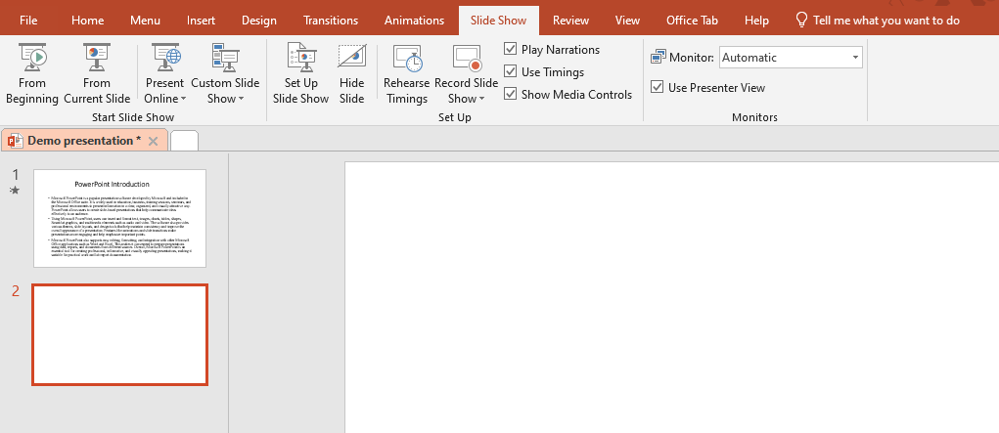
The Slide Show tab in Microsoft PowerPoint is used to control how a presentation is delivered to the audience. It provides tools to start, customize, and rehearse slide shows, helping presenters deliver their content smoothly and professionally. This tab is essential for preparing and presenting slides effectively, ensuring that the audience experiences the presentation as intended.

Key Features of the Slide Show Tab:
- From Beginning / From Current Slide: These options allow users to start the slide show either from the first slide or from the currently selected slide. This is useful for practicing or presenting specific sections.
- Custom Slide Show: This feature allows users to create a customized sequence of slides for different audiences or purposes, without changing the main presentation.
- Set Up Slide Show: Users can configure how the slide show will run, including options for looping, showing slides in a specific order, or presenting on multiple monitors.
- Rehearse Timings: This tool helps presenters practice their presentation and record the time spent on each slide. It is useful for pacing and preparing for timed presentations.
- Record Slide Show: This feature allows users to record narration, slide timings, and annotations, creating a self-running presentation that can be shared with others.
- Hide Slide: Users can temporarily hide slides from the slide show without deleting them, allowing flexibility in presentations.
- Play Narrations / Use Timings: These options allow recorded narrations and slide timings to be included or excluded during the presentation, providing full control over delivery.

8.Conclusion
Microsoft PowerPoint is a versatile and powerful tool for creating professional and visually appealing presentations. By using its various tabs and features, such as Home, Insert, Design, Transitions, Animations, and Slide Show, users can effectively organize, format, and enhance content to communicate ideas clearly. PowerPoint allows the integration of text, images, charts, multimedia, and animation, making presentations more engaging and interactive. Understanding and utilizing these features helps users deliver information in a structured and visually appealing manner, improving both learning and communication outcomes. Overall, Microsoft PowerPoint is an essential application for academic, professional, and personal presentations, providing a platform to present ideas creatively and effectively.

